BLINKIT ANALYSIS

* **See all the Data imported:**

SELECT * FROM blinkit_data

* **Data Cleaning:**

UPDATE blinkit_data

SET Item_Fat_Content =

CASE

WHEN Item_Fat_Content IN ('LF', 'low fat') THEN 'Low Fat'

WHEN Item_Fat_Content = 'reg' THEN 'Regular'

ELSE Item_Fat_Content

END

After executing this query check the data has been cleaned or not using below query

SELECT DISTINCT(Item_Fat_Content) FROM blinkit_data

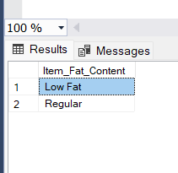

1. **KPI’s Requirements**
2. **Total Sales:-**

SELECT CAST(SUM(Total_Sales)/1000000 AS DECIMAL(10,2)) AS Total_Sales_Millions

FROM blinkit_data

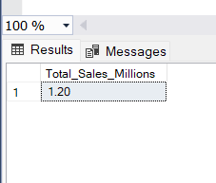

1. **Average Sales:-**

SELECT CAST(AVG(Total_Sales) AS DECIMAL(10,0))AS Avg_Sales

FROM blinkit_data

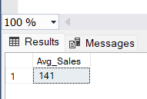

1. **No. of Items:-**

SELECT COUNT(*) AS No_of_Items FROM blinkit_data

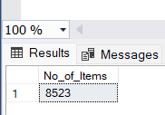

1. **Average Ratings:-**

SELECT CAST(AVG(Rating) AS DECIMAL(10,2)) AS Avg_Ratings FROM blinkit_data

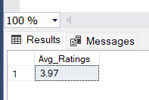

1. **Chart Requirements**
2. **Total Sales by Fat Content:-**

SELECT Item_Fat_Content,

CONCAT(CAST(SUM(Total_Sales) AS DECIMAL (10,2)),' K') AS

Total_Sales_Thousands,

CAST(AVG(Total_Sales) AS DECIMAL(10,2)) AS Avg_Sales,

COUNT(*) AS No_of_Items,

CAST(AVG(Rating) AS DECIMAL(10,2)) AS Avg_Ratings

FROM blinkit_data

GROUP BY Item_Fat_Content

ORDER BY Total_Sales_Thousands DESC

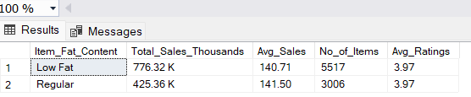

1. **Total Sales by Item Type:-**

SELECT Item_Type,

CAST(SUM(Total_Sales)/1000 AS DECIMAL(10,2)) AS Total_Sales_Thousands,

CAST(AVG(Total_Sales) AS DECIMAL(10,1)) AS Avg_Sales,

COUNT(*) AS No_of_Items,

CAST(AVG(Rating) AS DECIMAL(10,2)) AS Avg_Ratings

FROM blinkit_data

GROUP BY Item_Type

ORDER BY Total_Sales_Thousands DESC

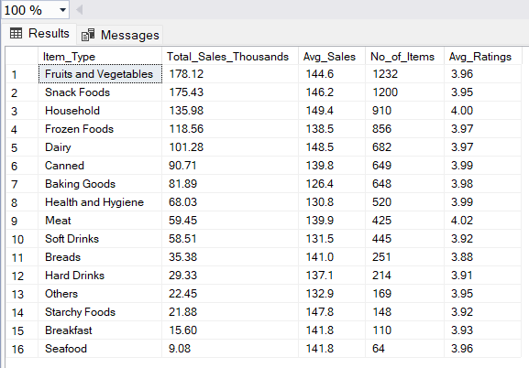

1. **Fat Content by Total Sales:-**

SELECT Outlet_Location_Type,

ISNULL ([Low Fat], 0) AS Low_Fat,

ISNULL ([Regular], 0) AS Regular

FROM

( SELECT Outlet_Location_Type, Item_Fat_Content,

CAST(SUM(Total_Sales)/1000 AS DECIMAL(10,2)) AS

Total_Sales_Thousands

FROM blinkit_data

GROUP BY Outlet_Location_Type, Item_Fat_Content

) AS Source_Table

PIVOT

(

SUM(Total_Sales_Thousands)

FOR Item_Fat_Content IN ( [Low Fat], [Regular])

) AS Pivot_Table

ORDER BY Outlet_Location_Type;

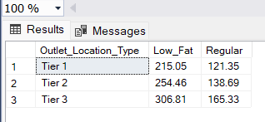

1. **Total Sales by Outlet Establishment:-**

SELECT Outlet_Establishment_Year,

CAST(SUM(Total_Sales)/1000 AS DECIMAL(10,2)) AS Total_Sales_Thousands,

CAST(AVG(Total_Sales) AS DECIMAL(10,1)) AS Avg_Sales,

COUNT(*) AS No_of_Items,

CAST(AVG(Rating) AS DECIMAL(10,2)) AS Avg_Ratings

FROM blinkit_data

GROUP BY Outlet_Establishment_Year

ORDER BY Outlet_Establishment_Year

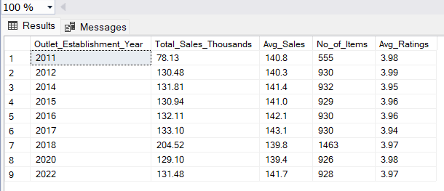

1. **Percentage of Sales by Outlet Size:-**

SELECT Outlet_Size,

CAST(SUM(Total_Sales) AS DECIMAL(10,2)) AS Total_Sales,

CAST(SUM(Total_Sales) * 100.0 / SUM(SUM(Total_Sales)) OVER() AS

DECIMAL(10,2)) AS Sales_Percentage

FROM blinkit_data

GROUP BY Outlet_Size

ORDER BY Total_Sales Desc

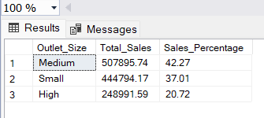

1. **Sales by Outlet Location:-**

SELECT Outlet_Location_Type,

CAST(SUM(Total_Sales)/1000 AS DECIMAL(10,2)) AS Total_Sales_Thousands,

CAST(AVG(Total_Sales) AS DECIMAL(10,1)) AS Avg_Sales,

COUNT(*) AS No_of_Items,

CAST(AVG(Rating) AS DECIMAL(10,2)) AS Avg_Ratings

FROM blinkit_data

GROUP BY Outlet_Location_Type

ORDER BY Total_Sales_Thousands DESC

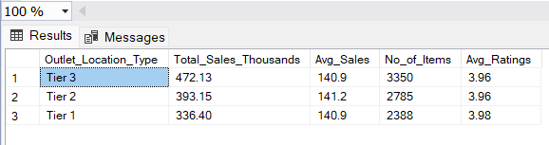

1. **All Metric By Outlet Type:-**

SELECT Outlet_Type,

CAST(SUM(Total_Sales)/1000 AS DECIMAL(10,2)) AS Total_Sales_Thousands,

CAST(AVG(Total_Sales) AS DECIMAL(10,1)) AS Avg_Sales,

COUNT(*) AS No_of_Items,

CAST(AVG(Rating) AS DECIMAL(10,2)) AS Avg_Ratings

FROM blinkit_data

GROUP BY Outlet_Type

ORDER BY Total_Sales_Thousands DESC

